1. How many Namespaces exist on the system?

5

1. How many pods exist in the kube-system namespace?

7

1. Create a deployment with Name: beta Image: redis Replicas: 2 Namespace: finance Resources Requests: CPU: .5 vcpu Mem: 1G Resources Limits: CPU: 1 vcpu Mem: 2G

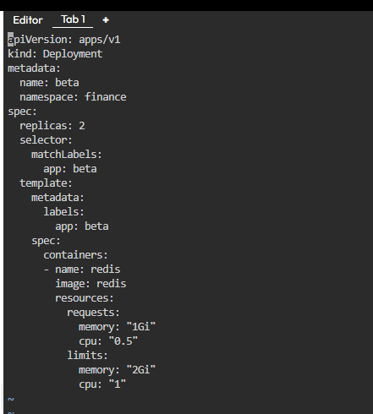

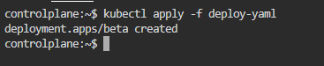

1. How many Nodes exist on the system?

1

1. Do you see any taints on master?

No

1. Apply a label color=blue to the master node

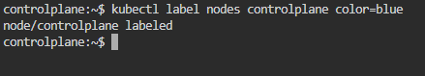

7- Create a new deployment named blue with the nginx image and 3 replicas

Set Node Affinity to the deployment to place the pods on master only NodeAffinity: requiredDuringSchedulingIgnoredDuringExecution

Key: color

values: blue

